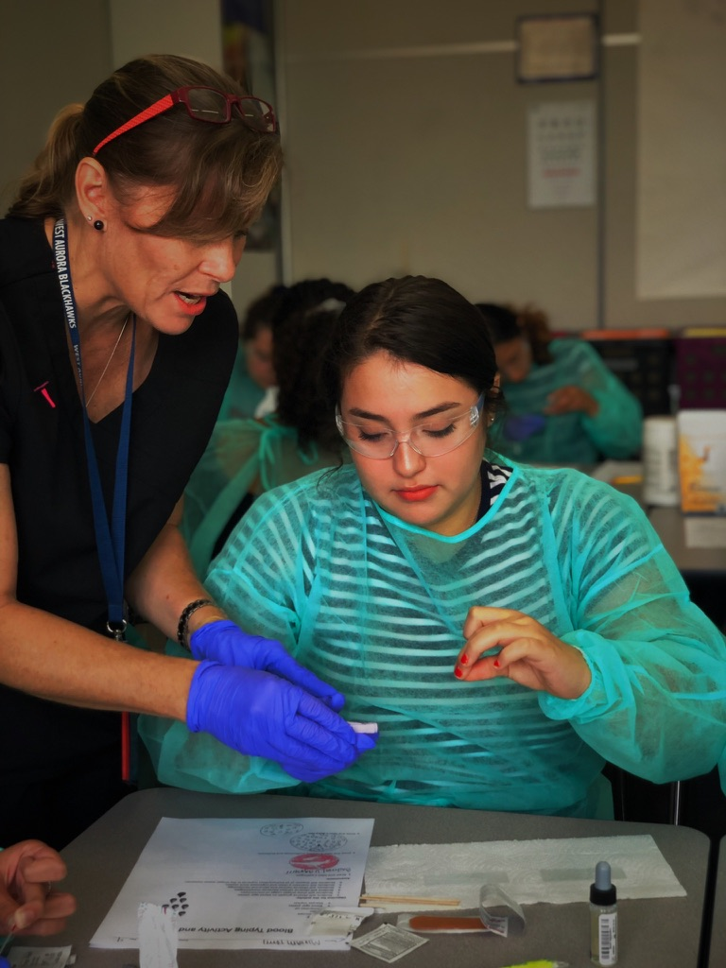
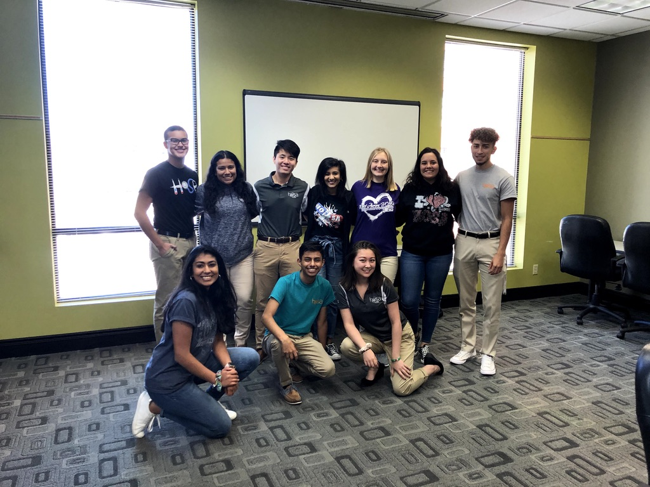
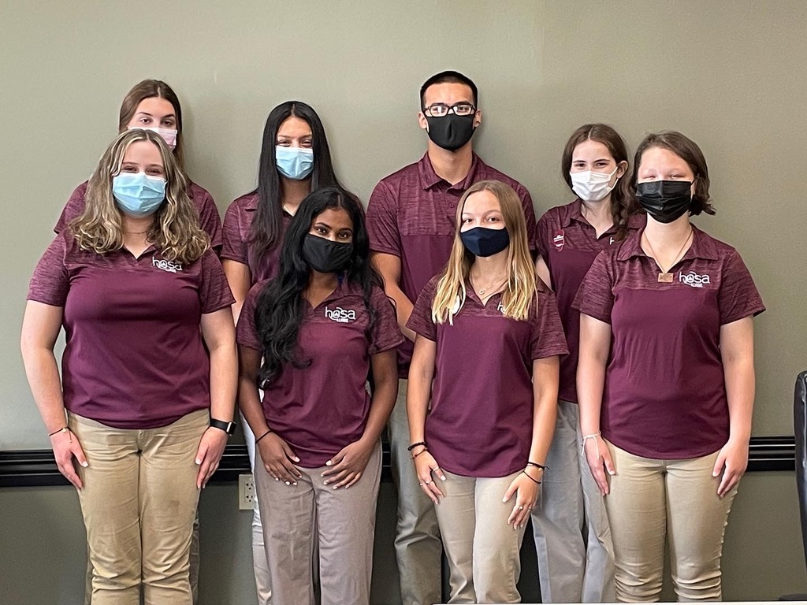

How to Join Illinois HOSA

How to Start a Chapter
Contact Illinois HOSA-Future Health Professionals and indicate your interest in affiliating your school/college and students with the state association and national organization.
You will first need to register your chapter members through the national online affiliation system. This system allows you to affiliate members, view your account balance, print your membership directory, complete online registration for conferences, and more. In other words, this is where you’ll do almost everything for your chapter.
In order to use the national online affiliation system, you must obtain a chapter number and password from Illinois HOSA. Our state advisor, April Sonnefeldt, is an excellent source of information regarding conferences, our national service project, and services available to chapter advisors and members. Please contact her with any questions.

Step 1: Contact Illinois HOSA Executive Director
- April Sonnefeldt Email: asonnefeldt@sd129.org
Step 2: Decide what method your institution will use to organize your HOSA Chapter
A single chapter is formed for all students in all classes regardless of the number of instructors. This is the preferred method for high school and post high school institutions (community colleges, technical schools and four-year colleges) where multiple instructors offer multiple courses. If this method is adopted, every effort must be made to get 100% active involvement by all students and instructors.
Instructor based chapter (One chapter with many committees)
One instructor forms a chapter for all students enrolled in his/her classes. While chapter meetings with all students may be difficult to schedule, individual classes can form in-class committees to plan and organize projects and activities. Each class can elect a vice president (class representative) that serves on a HOSA Chapter Council, the steering committee for the chapter.
Classroom based chapter (Several chapters; For institutions where students are unable to meet regularly)
A HOSA chapter is formed for each class of five (5) or more students with one (1) advisor. The instructor could organize multiple chapters that will conduct their business meetings and activities independent of each other. Each chapter elects an officer team, and for large projects, chapters can collaborate. (Business meetings and programs can be held during class time since HOSA is “curricular” and not “extracurricular.”)

Step 3: Adopt and review the Chapter Bylaws
Step 4: Recruit Members
Step 5: Address Fees
Establish processes for collecting funds and paying bills, according to your district’s/college’s policy and collect membership fees. Membership Dues are to be submitted by ______ to participate in HOSA activities
Yearly student and advisor membership fees are _______ These must be paid for members to be part of HOSA-Future Health Professionals. In addition, a chapter can decide to collect local chapter fees.
Do not affiliate members or register them for conferences until the student has paid.

Step 6: Host your first chapter meeting
Have members vote to approve the bylaws. Elect Chapter Officers. Consider planning fundraisers to support the activities you plan to hold. Introduce your members to HOSA and what it has to offer.
The HOSA, Inc. Board contracts with Awards Unlimited (Market Place) to provide the HOSA Supply Service. A current catalog is online, and products can be viewed and/or ordered at www.awardsunlimited.com.

Step 7: Get Involved
Illinois HOSA holds the following yearly Conferences
- Fall Leadership Conference (FLC)
- Leadership training for chapter officers
- State Leadership Conference (SLC)
- Second Level of Competitive Events
- Election of State Officers
- Award/Recognition Ceremony
- International Leadership Conference (ILC)
- Final Level of Competitive events
- Held for all Chapters associated HOSA-Future Health Professionals
- Recognizes outstanding performance in leadership and competitions
- During the conference, members can network and have the opportunity to attend educational symposiums about current healthcare issues
- Additionally, the leadership of HOSA, Inc. and HOSA-FHP meets and elects new representatives and officers

